For more than 25 years and over 3,000 project Kasco has been building the skyline of Detroit. Our Client List includes the most recognizable name plates in Southeastern Michigan, including Henry Ford Health System, Beaumont Health, the University of Michigan and many others. Clients who require quality, experience and expertise have come to rely upon Kasco.

A
American Automobile Association (AAA) | 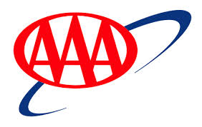
Accessories by Stephanie
Adam Waechter
Adamation
Allen Technologies
Alps Automotive, Inc.
American Consolidated Tech
Archdiocese of Detroit
Ascension Health Ministry
Askar Management Group LLC
Associated Endocrinologists
Automated Systems Inc.

B
Barton Malow Company
Be Well Medical
Bedrock Real Estate Services
Bernco, Inc.
Bishop Real Estate, L.L.C.
Blarney Stone Pub
Bloomfield Township | 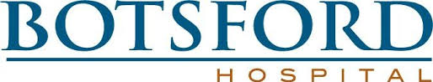
Botsford Hospital
Bridge of Life Center
Bridge Tech

C
Cardinal Health
Cardiology & Vascular Associates
Cardiovascular Consultants, PC
Cat Tails
Cellular and More
Center for Physical Medicine
Center for Plastic and
Chandler Park Academy
Chi Phi Fraternity
Children’s Hospital of Michigan
Church of Christ
City of Auburn Hills | 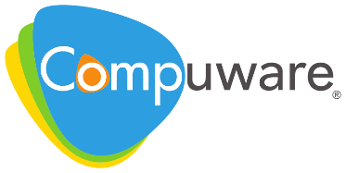
Commerce MOB, LLC
Commerce Property Management
Commercial Properties Services LLC
Community Bank of Dearborn
Compuware Corporation
Compuware Sports Arena
Consumers Energy
Core Partners
Cranbrook Educational Community

D
Delta Fraternity
Denali Development Group, LLC
Detroit Institute of Arts
Detroit Police Department
Downriver Internists
Dr. Cahill
Dr. David Baird
Dr. Dolores Baran
Dr. Ed Haenick
Dr. Jarodiya
Dr. Khandwala
Dr. Maxwell
Dr. Paul Benson
DTE

E
Eastern Michigan University | 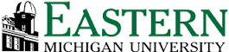
Edcor
Etkin Equities
Evangelical Homes of Michigan
Everest Academy
Extreme Engineering

F
Felician Sisters
Fifth Third Bank | 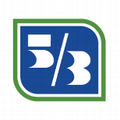
First Church of Christ
First Federal of Michigan
First State Bank
First Step, LLC
Foley & Associates
Forbes Trail Development
Franklin High School
Frito Lay

G
G.M.A. Capital
Gale Force Sports & Entertain
Glacier Hills, Inc.
Goodwill Industries
Guardian Angels Church

H
H & R Block | 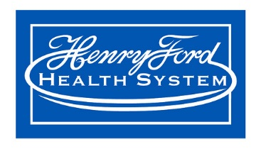
Harrison Loft Development Co,
Henry Ford Community College
Henry Ford Health System
Higgins Development Partners
Hillel Day School
Hines Detroit Services LLC
Hospital Consolidated Labs
Huntington Medical Group
Huntington Woods Police Department
Huron Pointe Properties, LLC

I
Illusions by Sherri
Independence Management Corporation
Integrated Health Associates
ISCG
Island Lake Condominiums

J
Jabs Gym LLC | 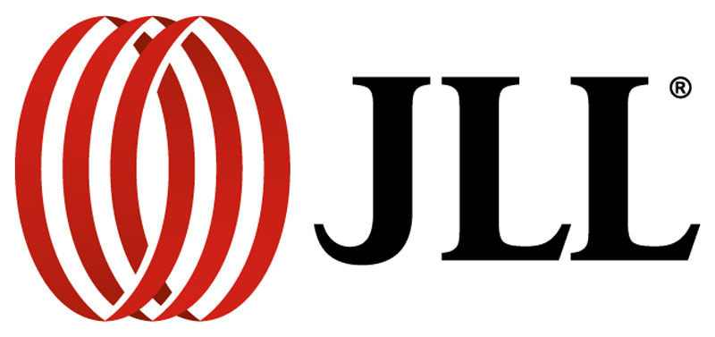
Jeffrey Cohen, DDS, P.C
Jewish Apartments & Services
Jewish Senior Life
Jewish Vocational Services
Jones Lang LaSalle

K
Karmanos Cancer Center | 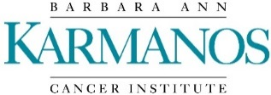
Keystone Dialysis, LLC
Kindred Health

L
Levan Medical Associates
Lourdes Nursing Home
Lutheran Home

M
Macomb Orthopedics
Manoogian Manor
McLaren Health – Oakland
McPhearson Professional Building
Methodist Children’s Home
MI Department of Corrections
MI Schools & Government Credit Union
MI Comprehensive Cancer Ins
MI Home for Armenian Aged
Michigan Heart P.C.
Michigan Mobile Imaging
Michigan Physicians Group
Milford Township
Milford Department of Public Works
Monroe Mercy Memorial Hospital
Morgan Stanley
Motorola
MSU

N
Nana’s Investments LLC
NBS
New Hope Baptist Church
Niagara Murano
North American Biologicals, Inc
North Hills Christian Reformed
North Oakland Medical Center

O
Oakland Manor Nursing & Rehab | 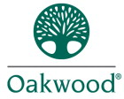
Oakland University
Oakwood Beyer Hospital Center
Oakwood Healthcare System
Ollie’s Restaurant
Oral and Facial Surgeons
Orchard Pediatrics

P
PAC Federal Credit Union
Papa Romano’s
Pet Supplies Plus SCS
Pioneer Specialty Hospital
Pleasant Grove Baptist Church
Pontiac Academy for Excellence
Public Service Credit Union

R
Rainbow Rehabilitation Centers
Rent-A-Center
Republic Bank Brighton
Richardson Foods
Rodgers Chevrolet
Romeo Investment Ltd. LLC
Royal Oak Medical Devices, LLC
Royal Oak Retail Management

S
Sarnacki & Associates
Sava Senior Care
SCCI Hospital
Secretary of State
Seger Financial
Select Specialty Hospital
Shift Digital
Shildan, Inc
Siemens Medical Solutions
Skanska
Sodexo Healthcare Services
Sony Electronics Inc.
South Lyon Home
South Main Realty, LLC
St. Clair Shores MOB
St. John Providence Health Sys
St. Joseph Mercy Hospital
St. Mary H.O.P.D.
St. Mary Mercy Hospital
St. Thomas Lutheran Church
St. Thomas More
Sterling Land Investors, LLC
Stucchi’s Ice Cream
Subway Corporate

T
The Huntington Group
The Promanas Group
Trinity Senior Living Community
Triumph Healthcare

U
U of M Athletic Department
U of M Credit Union
United Jewish Foundation
University Neurosurgical Associates
University of Michigan
UPMC
Urology Specialists of Michigan
USA Federal Credit Union

V
Varian Medical Systems
Viox Services, Inc

W
Warren Bank
Washington Township Real Estate
Washtenaw County Downtown Center
Weldaloy
West Bloomfield MOB, LLC
West Hickory Haven
Westland Retail Management
WHC-IRS Center Limited Partner
Williamson Dental
Windham Group, LLC
Winfire Co

